## Access and Add Files to your Team

1. Select a Team where you want to access Files.

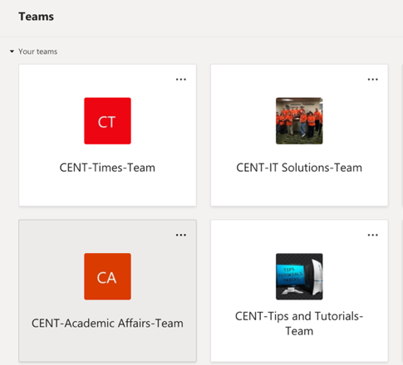

1. Click a channel on the left side.

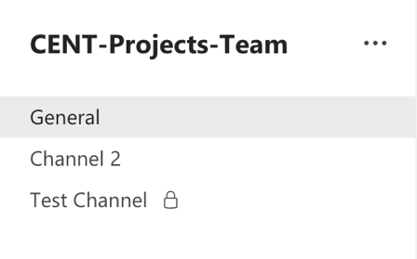

1. Click **Files** at the top.

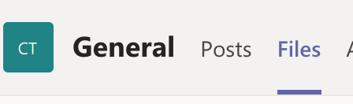

1. You will see a list of files and/or folders. Click on a file to view/edit it.
2. Select **Upload** to add a file from your computer or **New** to create a new file in Teams.

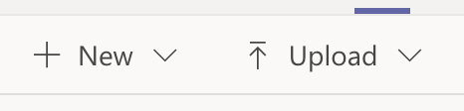

## Create Posts in your Team

Posts is a fast, easy way to communicate within your team!

### Create a Post

1. Click the button **New Conversation**.
2. Start typing in a post. You can use various tools below the field to determine how your post looks:

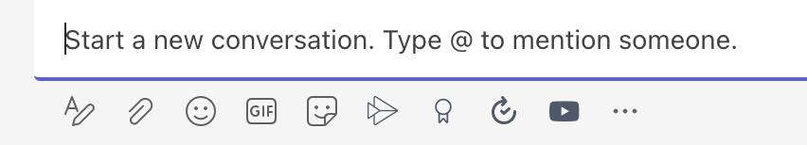

* Format: Click the A with the pen to access additional formatting options for your post
* Attach: Attach a file with your post. Be mindful that if you do this, the file will be automatically added to the files section and may disrupt existing file organization.
* Emoji, Gif, Stickers: Attach emojis, gifs, and stickers to your post

1. Type **@teammembername** to **mention** someone and get their attention.
2. Type **@TeamName** or **@channelname** to **mention** the whole Team or channel and notify everyone
3. Press **Enter** on your keyboard, or click the triangular **Send** button to make a post.

### Reply to a Post

Like in social media, you can respond to someone’s post without having to make a new one!

1. Click the **Reply** button below a post. Type your response and click the triangle button to the right to post your reply.
2. **React** to a post by moving your mouse in the top right corner of the post and click an emoji.