PART 1: Notating rhythmic values
On the middle line of the following staves:

1. Draw four whole notes. | 2. Draw four half notes: two with upstems, two with downstems.
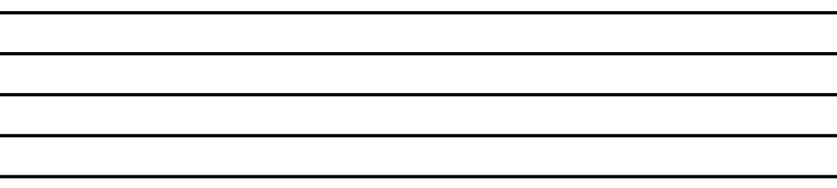

- Draw four quarter notes on the middle line: two with upstems and two with downstems.

Note and Rest Values

Name: _______________________________________________
4. Draw four flagged eighth notes: two with upstems and two with downstems. | 5. Draw a pair of eighth notes, beamed together, with downstems.

6. Draw four flagged sixteenth notes: two with upstems and two with downstems. | 7. Draw a set of four sixteenth notes, beamed together, with upstems.

8. Draw four flagged sixteenth notes: two with upstems and two with downstems. | 9. Draw a set of four sixteenth notes, beamed together, with upstems.

10. Draw four flagged thirty-second notes: two with upstems and two with downstems. | 11. Draw a set of eight thirty-second notes, beamed together, with upstems.

PART 2: Notating rests
Draw four of each of the requested rest values on the staves below.

12. Whole rests | 13. Half rests

14. Quarter rests | 15. Eighth rests
16. Sixteenth rests | 17. Thirty-second rests

PART 3: Rhythm Math
Solve the following rhythmic equations.
- A quarter note = 1.
- Your answers may not always be whole numbers.

18. | 𝅝 + 𝅗𝅥 + 𝅘𝅥 + 𝅘𝅥𝅮 | =
19. | 𝅘𝅥𝅯 + 𝅘𝅥𝅯 + 𝅘𝅥𝅮 + 𝅗𝅥 | =
20. | 𝅘𝅥𝅮 + 𝅘𝅥 + 𝅘𝅥 + 𝅗𝅥 | =
21. | 𝅘𝅥𝅮 + 𝅗𝅥 + 𝅝 + 𝅘𝅥𝅯 + 𝅘𝅥 + 𝅘𝅥𝅯 | =
22. | 𝅘𝅥 + 𝅘𝅥𝅯 + 𝅘𝅥𝅮 + 𝅘𝅥𝅯 + 𝅗𝅥 | =
23. | 𝅗𝅥 + 𝅘𝅥𝅯 + 𝅘𝅥𝅯 + 𝅘𝅥 + 𝅘𝅥𝅮 | =
24. | 𝄼 + 𝄾 + 𝄽 + 𝄽 + 𝄿 + 𝄿 | =
25. | 𝄽 + 𝄿 + 𝄻 + 𝄼 + 𝄿 | =
26. | 𝄾 + 𝄼 + 𝄿 + 𝄽 | =
27. | 𝄼 + 𝄿 + 𝄾 + 𝄽 + 𝄿 | =
28. | 𝄾 + 𝄻 + 𝄽 + 𝄽 + 𝄻 | =
29. | 𝄽 + 𝄼 + 𝄻 + 𝄻 + 𝄽 | =

