PART 1: Dynamics

Other Aspects of Notation

Name: _______________________________________________

- In the blanks below, order the following dynamics below, from softest to loudest.
mf ppp ff mp f p
Softest Loudest

______ | ______ | ______ | ______ | ______ | ______

- What is the difference between a crescendo and decrescendo?

- Why are “hairpins” so named?

- Is there a difference between a decrescendo and a diminuendo?

- Draw either a crescendo or decrescendo hairpin between the following dynamic markings below the staff (you will need one of each).
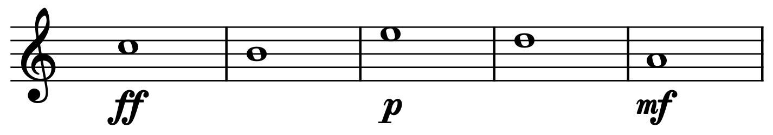

PART 2: Articulation
- Draw a slur connecting the first note to the last note.
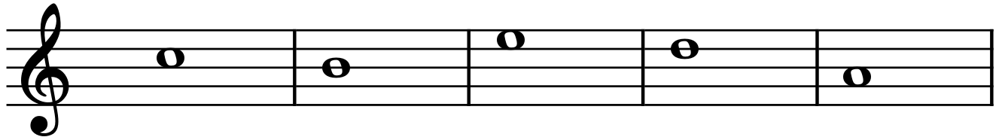

- Draw tenuto markings above each note.
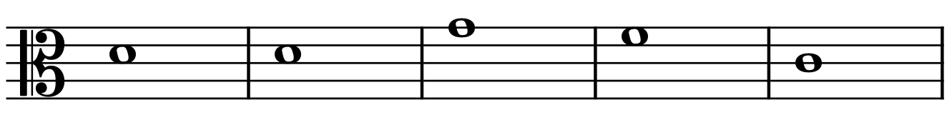

- Draw staccato markings above each note.
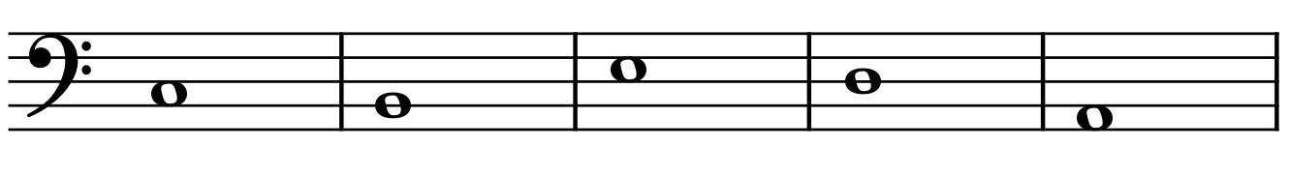

- Draw marcato markings above each note.
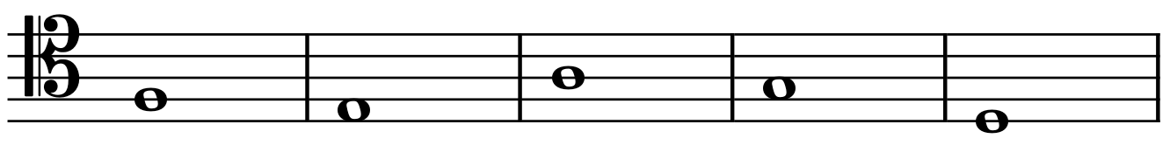

- Draw accents above each note.
PART 3: Tempi
- In the blanks below, order the following tempi, from slowest to fastest.
Andante | Grave | Presto | Allegro | Adagio | Vivace

Slowest Fastest
______ | ______ | ______ | ______ | ______ | ______

- What are the four slow tempi?

- What does cantabile mean?

- What is the difference between a ritardando and an accelerando?

PART 4: Structural Features
- Draw five fermatas, one above each note.
- Draw five caesuras, one after each note.
- Draw five breath marks, one after each note.
- Draw repeat signs at the beginning (after the clef) and the end.
- In measure 5, draw a first ending bracket and a repeat sign; in measure 6, draw a second ending bracket and a final barline.
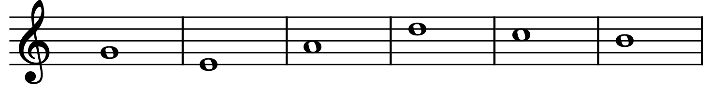
PART 5: Stylistic Periods
- Order the following stylistic periods below in the blanks, from oldest to most recent.

Classical | Renaissance | Romantic | Medieval | Post-Tonal | Baroque

Oldest Most Recent

______ | ______ | ______ | ______ | ______ | ______

- What are the generally agreed-upon years of the Classical era?

- What are the generally agreed-upon years of the Baroque era?

- What are the generally agreed-upon years of the Romantic era?

- What are the generally agreed-upon years of the Renaissance era?

