
Spotify playlist
(link on textbook
website)

Foundational Concepts for
LINK

Phrase-level Forms

Name: _______________________________________________

PART 1
John Williams, “Hedwig’s Theme” from Harry Potter

- Listen to the excerpt. (0:00–0:35)
- On the score below, four points of closure have been identified using letters (A, B, C, and D). These points of closure mark the ends of phrases, and not all of them involve traditional cadences. Besides harmony, what other feature tells us that these moments can be considered points of closure?
____________________________________________________________

- A segmentation analysis and motivic analysis have been started for you on the score below. The first idea has been bracketed, and two motives have been circled and labeled ‘X’ and ‘Y.’ Continue the analysis on the score by:
- finishing the segmentation analysis to show the complete idea level on the score, and
- identifying any recurrences of motives ‘X’ and ‘Y’ and labeling them appropriately.

- In the blank space immediately below, please draw a phrase diagram in which you show:
- the idea level,
- the phrase level, and
- the points of closure. (Use boxed C ’s to indicate these instead of a cadence label.)

Foundational Concepts for Phrase-Level Forms

Name: _______________________________________________

- Pick two of the motivic recurrences you have identified and explain what transformations have been applied to them.

____________________________________________________________________________________

____________________________________________________________________________________

____________________________________________________________________________________

____________________________________________________________________________________

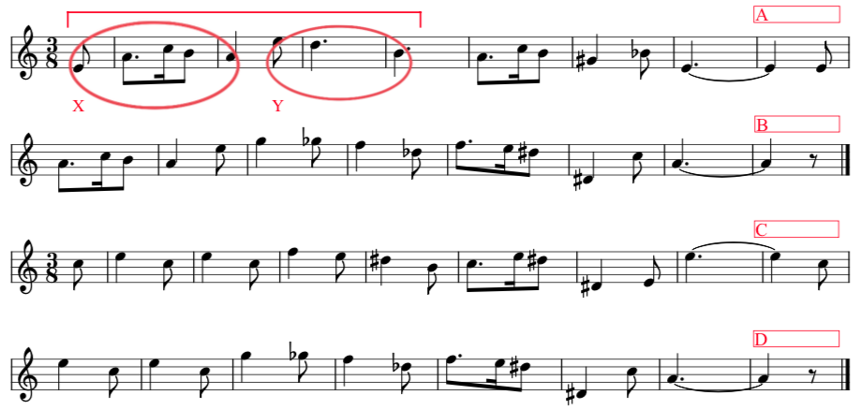

Foundational Concepts for Phrase-Level Forms

Name: _______________________________________________

PART 2
Omar Thomas, A Mother of a Revolution!

Note: This audio example is not on the worksheet playlist. Instead, use this URL:
https://youtu.be/R6ieR-YZ4eY

Performed by the Hodgson Wind Ensemble at the University of Georgia (Dr. Cynthia Johnston Turner, conductor). (Used by permission.)

- This exercise is audio-only, with no score to reference.
- Listen to the excerpt.
- An important motive is introduced at the beginning of the piece in the brass section at 0:32–0:38 (although there's certainly a sense in which the motive is foreshadowed by the percussion at 0:24–0:26). Identify at least three different transformations of this motive across the work by filling in the following blanks:

Timestamp Instrument(s) Transformation technique(s) applied
- ____________ ______________________ __________________________________________
- ____________ ______________________ __________________________________________
- ____________ ______________________ __________________________________________

PART 3
Maria Szymanowska, 18 Dances of Different Genres, Polonaise in E minor, Trio, mm. 1–8.

- Listen to the excerpt. (starts at 0:54)
- Identify all cadences directly on the score below.
- Provide a segmentation analysis on the score that shows the idea level.
- In the blank space immediately below, draw a phrase diagram that shows the idea level, the phrase level, and cadences:

Foundational Concepts for Phrase-Level Forms

Name: _______________________________________________

